9/20/2017

**Using Commandbox cfconfig**

**Here is link to documentation: https://cfconfig.ortusbooks.com/introduction/overview.html**

Install cfconfig from the box prompt with

Install commandbox-cfconfig –force (two dashes before “force”)

To move datasource configuration, here are samples from my Alion machine

Note we have a directory for ColdFusionSettings: C:/Users/dbellenger/Documents/ColdFusionSettings

In the first command, the from= points to a server definition in C:/Users/dbellenger/.CommandBox/server/. The FromFormat matches the directory name in the server definition.

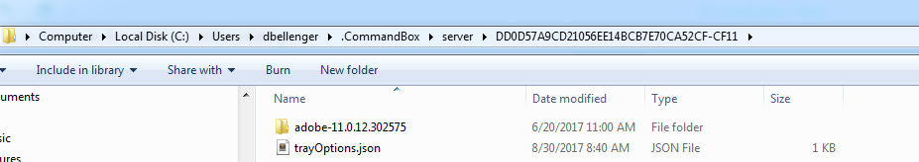

cfconfig export to=”C:/Users/dbellenger/My Documents/ColdFusionSettings/.CFConfig.json” from=C:/Users/dbellenger/.CommandBox/server/DD0D57A9CD21056EE14BCB7E70CA52CF-CF11/adobe-11.0.12.302575/WEB-INF/cfusion fromFormat=adobe@11.0.12.302575

This command brings the datasouce definitions INTO a different server from the file

cfconfig import from=”C:/Users/dbellenger/My Documents/ColdFusionSettings/.CFConfig.json” to=C:/Users/dbellenger/.CommandBox/server/D13C37744476A0394F25AF783465457F-CF11/adobe-11.0.12.302575/WEB-INF/cfusion toFormat=adobe@11.0.12.302575

Bring the same settings into a CF2016 server

cfconfig import from=”C:/Users/dbellenger/My Documents/ColdFusionSettings/.CFConfig.json” to=C:/Users/dbellenger/.CommandBox/server/BD99047899392C3F4945F8EE9711AA64-cf2016/adobe-2016.0.04.302561/WEB-INF/cfusion toFormat=adobe@2016.0.04.302561